**BASIC HTML TAGS**

|  |  |
| --- | --- |
| **TAGS** | **DESCRIPTION** |
| <!DOCTYPE> | Defines the document type |
| <html> | Defines HTML document |
| <head> | Contains information about document (title, metadata, etc) |
| <title> | Defines a title which appears on tab bar on web browser |
| <body> | Defines the body of the web page |
| <h1> | Used for writing heading (largest size) |
| <h6> | Used for writing heading (smallest size) |
| <br> | Inserts a blank line |
| <p> | Defines a paragraph |
| <hr> | Inserts a horizontal line |
| <b> | Used for writing the text in bold |
| <strong> | Defines important text |
| <sub> | Used for writing subscripted text |
| <sup> | Used for writing superscripted text |
| <form> | Defines HTML form for user input |
| <input> | Used for taking input from user |
| <textarea> | Used for taking multiple lines input |
| <select> | Used for making drop down menu |
| <img> | Used for inserting an image |
| <audio> | Used for inserting audio file on web page |
| <a> | Used for adding a link to the web page |

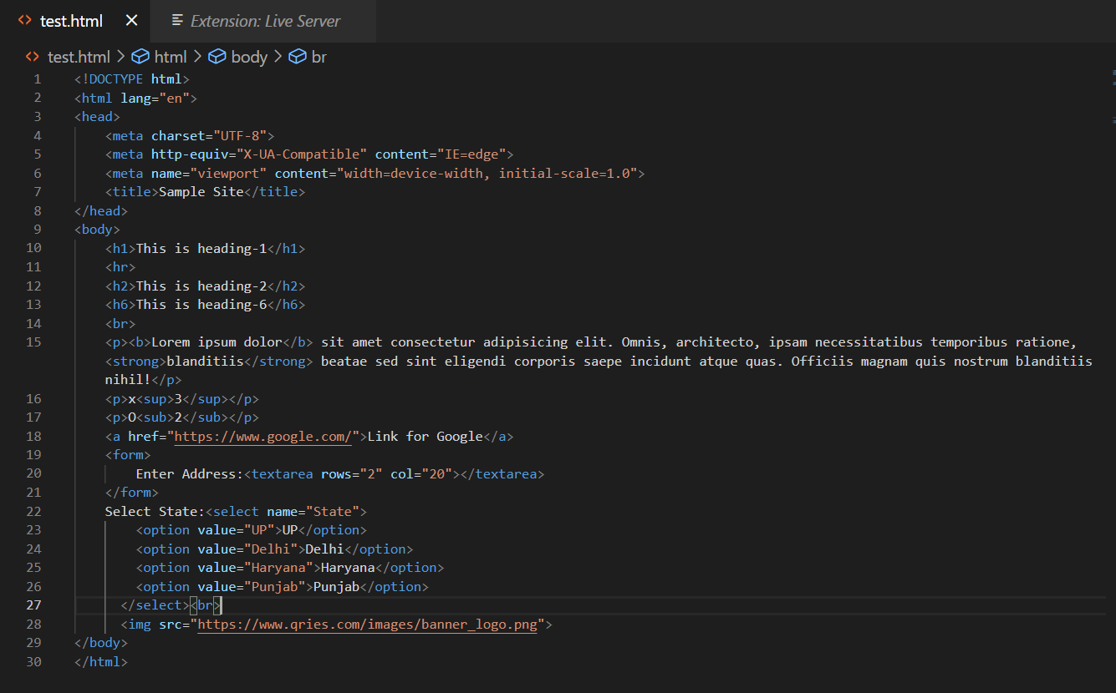

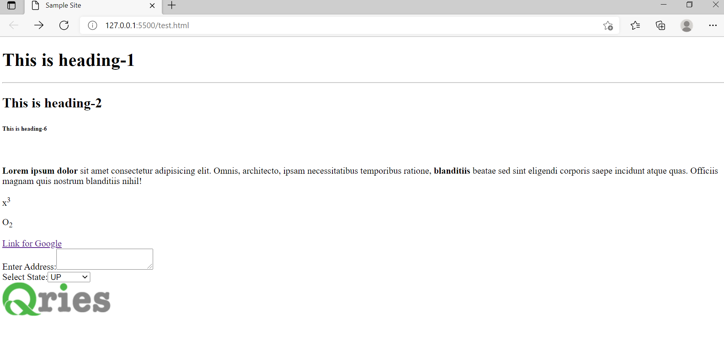

**By: Amogh Garg**

**2020UCO1688**

**COE-3**